Bluetooth communication protocol

Applicable instrument: HW8076

Table of contents

Instruction set
1. Bluetooth service UUID
2.Device Information服务
3. Transparent service
The app reads the scooter operation data script 0xA0
The app reads the scooter BMS data script 0xA1
The mobile phone sends the command code to read the skateboard information 0xB0
The APP issues the control data script 0xC0
Controller MCU upgrade
Request an upgrade script 0xD0
擦除MCU flash指令码 0xD1
The upgrade is completed 0xD3 the script
4.AT Instruction Service
Bluetooth Broadcast Name Query and Settings
Set/query encryption mode
Set/look up passwords
5. VCU upgrade service
Read VCU firmware version information
Send the upgrade package information
Send the upgrade file
CRC
Data encryption
Encryption
Encrypted byte description

Modify the record
Protocol version | Date | Modify the content
V1.0 | 2022-01-17 | First release
V1.1 | 2022-02-25 | Added VCU upgrade, added AT commands related to changing passwords, and changed the SN code acquisition method
V1.2 | 2022-09-13 | Modified cruise control speed limits
V1.3 | 2022-10-13 | Modified the software version number on page 11 and the software version number on page 21 BYTE4 and BYTE5
V1.4 | 2023-01-30 | Modified the MCU upgrade protocol
V1.5 | 2023-03-04 | Added a MAC address acquisition interface

Glossary
Acronym | Definition
BMS | Battery Management System
MCU | Motor Controller Uint
RPM | Revolution Per Minute
SN | Serial Number
VCU | Vehicle Control Unit
CMD | Command

Instruction set

Script | Description | Note:
0xA0 | Read the scooter operation data instructions | The app does not read the meter will also be automatically uploaded
0xA1 | Read battery data instructions | The app does not read the meter will also be automatically uploaded

Script | Description | Note:
0xB0 | Read version information and model instructions | Meters are not automatically uploaded

Script | Description | Note:
0xC0 | APP writes instructions | Set function switch signals, speed limit values, etc

Script | Description | Note:
0xD0 | Query if the controller allows upgrades
0xD1 | Erase the controller flash command
0xD2 | Upgrade data
0xD3 | The upgrade is complete

1. Bluetooth service UUID
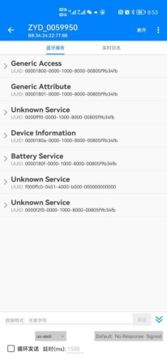
The above picture shows all the service channels of our Bluetooth chip, in this project we need to use 3 of them in addition to Device Information, namely:
UUID：0000fff0-0000-1000-8000-00805f9b34fb
UUID：0000f2f0-0000-1000-8000-00805f9b34fb
UUID：f000ffc0-0451-4000-b000-000000000000
The communication framework diagram is as follows:
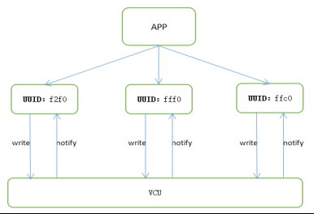

2.Device Information服务

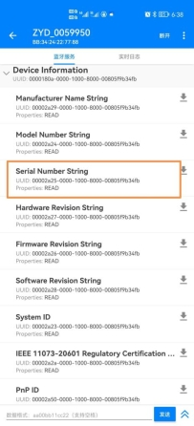
SN码通过Device Information的Serial Number String获取
SN code is in ascii code format, 13 characters

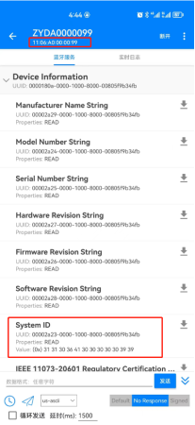

MAC通过Device Information的System ID获取
MAC is in ascii code format, 12 characters

3. Transparent service
透传服务UUID：0000fff0-0000-1000-8000-00805f9b34fb
透传接收UUID：0000fff1-0000-1000-8000-00805f9b34fb（write）
透传发送UUID:0000fff2-0000-1000-8000-00805f9b34fb(notify)

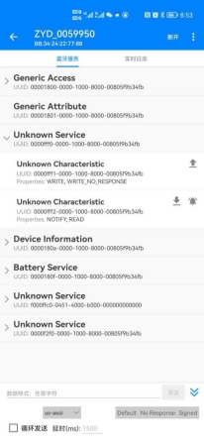
The app can obtain scooter operation data, BMS data, control scooter status and upgrade controllers through this service.
The frame diagram is as follows:
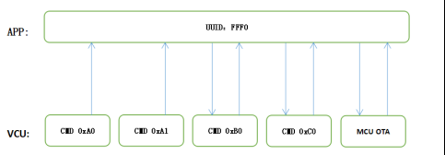

The app reads the scooter operation data script 0xA0
The app does not need to send this command to read the data, because the meter will actively upload this frame data at regular intervals.
Example:
Write: F0 A0 05 C9 F0
Notify: F0 A0 19 00 00 00 00 19 10 19 0A 00 00 10 00 C8 19 19 00 C8 00 00 00 03 4F

The parse of each byte looks like this:
app sends:
Serial number | Byte definition |  | Example
0 | Baotou |  | 0XF0
1 | Script |  | 0xA0
2 | Total number of bytes in the frame |  | 0x05
3 | CRC16 low bytes |  | 0xC9
4 | CRC16 High Bytes |  | 0xF0

Meter reply: (This package meter will be actively uploaded to the app at a scheduled time of 200ms).
Serial number | Byte definition | Example | Content definition | Note:
0 | Baotou | 0XF0
1 | Script | 0xA0
2 | Total number of bytes in the frame | 0x19 |  | 0x19=25
3 | Fault code high bytes | 0x00 |  | See definitions below
4 | Fault code low byte | 0x00 |  | See definitions below
5 | Control function high bytes | 0x00 |  | See definitions below
6 | Control function low byte | 0x00 |  | See definitions below
7 | Cruise control speed setting | 0x19 | 5-25km/h can enter the fixed speed cycle | 0x19=25km/h
8 | Current speed | 0x10 |  | 0x10=16km/h
9 | Maximum speed limit | 0x19 | Maximum speed 25km/h | 0x19=25km/h
10 | Subtotal mileage | 0x0A | Mileage of this ride | 0x0A=10km
11 | Total mileage is high bytes | 0x00 |  | Km
12 | Total mileage is low bytes | 0x00 |  | Km
13 | Remaining range | 0x10 | Based on the power estimate | 0x10=16km
14 | The current limit value is high bytes | 0x00 | Unit 0.1A | 0x00C8=200 represents 20A
15 | The current limit value is low bytes | 0xC8 | Unit 0.1A | 0x00C8=200 represents 20A
16 | Current motor temperature | 0x19 | Range 0-255°C | 25℃
17 | Current controller temperature | 0x19 | Range 0-255°C | 25℃
18 | The current motor speed is high in bytes | 0x00 | Units RPM | 200RPM
19 | The current motor speed is low bytes | 0xC8 | Units RPM | 200RPM
20 | Retained | 0x00
21 | Retained | 0x00
22 | Retained | 0x00
23 | CRC16 low bytes | CRCL |  | MODBUS——CRC16
24 | CRC16 High Bytes | CRCH |  | MODBUS——CRC16

Control function byte definition:
Bit7-Bit6 | Bit5 | Bit4 | Bit3-Bit2 | Bit1-Bit0
Turn signals: 0x0: Off 0x1: Turn right  0x2: Turn left | Cruise control switch:  0: Off 1: On | Headlights:  0: Off 1: On | Retained | Gear: 0x0: 1 gear 0x1: 2 gears  0x2: Gear 3

Bit15-Bit11 | Bit10 | Bit9 | Bit8
Retained | Boot mode: 0: Glide start 1: Zero start | Unit: 0:Km 1:Mile | Locked status: 0: Unlocked 1: Locked

Trouble code byte definition:
Fault code | Description
Bit0
Bit1 | 0: Normal 1: Brake finger derailment is faulty
Bit2 | 0: Normal 1: Throttle finger flip fault
Bit3 | 0: Normal 1: Instrument and controller communication failure
Bit4 | 0: Normal 1: Controller overcurrent
Bit5 | Retained
Bit6 | Retained
Bit7 | 0: Normal 1: Hall fault
Bit8 | Retained
Bit9 | 0: Normal 1: Op amp bias fault
Bit10-bit15 | To be defined
E0: Motor Temp Out of RangeE1: Brake FaultE2: Throttle FaultE3: Communication FaultE4 Overcurrent FaultE5: Undervoltage FaultE6: Overvoltage Fault
E7: Motor Hall FaultE8: Motor Phase Fault
E9: MCU Over TemperatureE10: MCU Temp Out of RangeE11: Motor Over TemperatureE12: Bluetooth FaultE13: Battery Fault

The app reads the scooter BMS data script 0xA1
The app does not need to send this command to read the data, because the meter will actively upload this frame data at regular intervals.
Example:
Write: F0 A1 05 C8 60
Notify: F0 A1 19 00 00 00 0A 01 A4 64 00 10 0F A0 0F A0 19 00 00 00 00 00 00 A2 C0

The parse of each byte looks like this:
app sends:
Serial number | Byte definition | Example
0 | Baotou | 0XF0
1 | Script | 0xA1
2 | Total number of bytes in the frame | 0x05
3 | CRC16 low bytes | 0xC8
4 | CRC16 High Bytes | 0x60

Meter reply: (This package meter will be actively uploaded to the app at a scheduled time of 200ms).
Serial number | Byte definition | Example | Content definition | Note:
0 | Baotou | 0XF0
1 | Script | 0xA1
2 | Total number of bytes in the frame | 0x19
3 | The battery status is high bytes | 0x00 |  | See definitions below
4 | Battery status low bytes | 0x00 |  | See definitions below
5 | The battery current is high in bytes | 0x00 | Symbolized unit 0.1A | 0x000A = 10 1.0A
6 | Low battery current | 0x0A | Symbolized unit 0.1A | 0x000A = 10 1.0A
7 | The current voltage of the battery is high bytes | 0x01 | Unit 0.1V | 0x01A4 = 420 42.0V
8 | The current voltage of the battery is low bytes | 0xA4 | Unit 0.1V | 0x01A4 = 420 42.0V
9 | Current battery level | 0x64 | Unit 1% | 100%
10 | The number of charging cycles is high | 0x00 |  | 0x0010 = 16 times
11 | The number of charging cycles is low bytes | 0x10 |  | 0x0010 = 16 times
12 | The battery capacity is high bytes | 0x0F | Unit mAh
13 | Battery capacity is low bytes | 0xA0 | Unit mAh
14 | The remaining capacity is high bytes | 0x0F | Unit mAh
15 | Low bytes of remaining capacity | 0xA0 | Unit mAh
16 | Battery temperature | 0x19 | There is a sign unit of °C | 0x19 = 25 25℃
17 | Retained | 0x00
18 | Retained | 0x00
19 | Retained | 0x00
20 | Retained | 0x00
21 | Retained | 0x00
22 | Retained | 0x00
23 | CRC16 low bytes | CRCL |  | MODBUS——CRC16
24 | CRC16 High Bytes | CRCH |  | MODBUS——CRC16

Note: Instruction 0xA#packet app can read without issuing commands The meter will automatically poll and upload these data
Battery status byte definition:
bit15-bit1 | bit0
Retained | Charging flag: 1 - Charged 0 - Not charged
Bit32-bit16
Retained

The mobile phone sends the command code to read the skateboard information 0xB0
Example:
Write: F0 B0 05 C4 30
Notify: F0 B0 20 00 01 30 30 30 30 30 30 30 30 30 30 30 30 30 00 00 00 10 10 20 20 30 30 00 00 00 F6 9E
The parse of each byte looks like this:
app sends:
Serial number | Byte definition | Example
0 | Baotou | 0XF0
1 | Script | 0xB0
2 | Total number of bytes in the frame | 0x05
3 | CRC16 low bytes | 0xC4
4 | CRC16 High Bytes | 0x30
Meter reply:
Serial number | Byte definition | Example | Content definition | Note:
0 | Baotou | 0XF0
1 | Script | 0xB0
2 | Total number of bytes in the frame | 0x19 |  | 0x19=25
3 | The model is high bytes | 0x00 | Model 0x0001=S008 Base
4 | Model low byte | 0x01 | Model 0x0001=S008 Base
5 | Instrument hardware version | 0x10 | Indicates version 1.0 | V1.0
6 | Instrument software version | 0x22 | Indicates version 2.2 | V2.2
7 | Controller hardware version | 0x20 | Indicates version 2.0 | V2.0
8 | Controller software version | 0x20 | Indicates version 2.0 | V2.0
9 | BMS hardware version | 0x30 | Indicates version 3.0 | V3.0
10 | BMS software version | 0x30 | Indicates version 3.0 | V3.0
11 | Retained | 0x00
12 | Retained | 0x00
13 | Retained | 0x00
14 | Retained | 0x00
15 | Retained | 0x00
16 | Retained | 0x00
17 | Retained | 0x00
18 | Retained | 0x00
19 | Retained | 0x00
20 | Retained | 0x00
21 | Retained | 0x00
22 | Retained | 0x00
23 | CRC16 low bytes | CRCL
24 | CRC16 High Bytes | CRCH

The APP issues the control data script 0xC0
The app can be used to control the scooter gear, headlight switch, cruise control switch, lock status, unit, start mode, speed limit value, etc.
Example:
Write: F0 C0 0F 00 00 19 19 00 00 00 00 00 00 39 E8
Notify: F0 C0 06 00 30 B8

The parse of each byte looks like this:
app sends:
Serial number | Byte definition | Example | Content definition | Note:
0 | Baotou | 0XF0
1 | Script | 0xC0
2 | Total number of bytes in the frame | 0x0F |  | 0x0A=10
3 | Control function high bytes | 0x00
4 | Control function low byte | 0x00
5 | Cruise control speed setting | 0x05 | Speed>=5km/h can enter the fixed speed cycle | 0x05=5km/h
6 | Maximum speed limit | 0x19 | Maximum speed 25km/h | 0x19=25km/h
7 | Retained | 0x00
8 | Retained | 0x00
9 | Retained | 0x00
10 | Retained | 0x00
11 | Retained | 0x00
12 | Retained | 0x00
13 | CRC16 low bytes | CRCL |  | MODBUS——CRC16
14 | CRC16 High Bytes | CRCH |  | MODBUS——CRC16
Data Reception Success Meter Response:
Serial number | Byte definition | Example
0 | Baotou | 0XF0
1 | Script | 0xC0
2 | Total number of bytes in the frame | 0x06
3 | State bytes | 0x00
4 | CRC16 low bytes | CRCL
5 | CRC16 High Bytes | CRCH
Status byte: 0x00 --data received successfully 0x01--CRC check-error

Control function byte definition:
Bit7-Bit6 | Bit5 | Bit4 | Bit3-Bit2 | Bit1-Bit0
 | Cruise control switch:  0: Off 1: On | Headlights:  0: Off 1: On | Retained | Gear: 0x0: 1 gear 0x1: 2 gears  0x2: Gear 3

Bit15-Bit11 | Bit10 | Bit9 | Bit8
Retained | Boot mode: 0: Glide start 1: Zero start | Unit: 0:Km 1:Mile | Locked status: 0: Unlocked 1: Locked

Controller MCU upgrade
During the upgrade process, if the instruction does not reply in 1s, resend it, and the upgrade is considered to have failed if the number of sends exceeds 5 times

MCU upgrade flow chart:


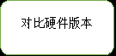

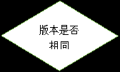


N
And
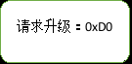





N
And
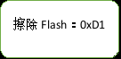

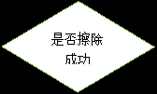

N

N



And And
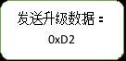

N


And N

Y N

And
And
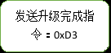




Before upgrading, you need to compare the hardware version of the MCU with the hardware version of the upgrade file, and the hardware version can only be upgraded if the hardware version is the same.
The maximum number of reoccurrences was 5 times, with a time interval of 1s.

Request an upgrade script 0xD0
App sending:
Serial number | Byte definition
0 | Baotou | 0xF0
1 | Script | 0xD0
2 | CRC16 low bytes | 0x44
3 | CRC16 High Bytes | 0x2C
Meter reply:
Serial number | Byte definition | Example
0 | Baotou | 0XF0
1 | Script | 0xD0
2 | State bytes | 0x00
3 | CRC16 low bytes | CRCL
4 | CRC16 High Bytes | CRCH
Status bytes: 0x00 - Upgrade allowed 0x01 - Upgrade not allowed

擦除MCU flash指令码 0xD1
App sending:
Serial number | Byte definition | Example
0 | Baotou | 0XF0
1 | Script | 0xD1
2 | CRC16 low bytes | 0x85
3 | CRC16 High Bytes | 0xEC
Meter reply:
Serial number | Byte definition | Example
0 | Baotou | 0XF0
1 | Script | 0xD1
2 | State bytes | 0x00
3 | CRC16 low bytes | CRCL
4 | CRC16 High Bytes | CRCH
Status bytes: 0x00--erase succeeded 0x01--erase failed

Send the upgrade data script 0xD2
The MCU upgrade file size is generally more than 40K, and the app needs to split the upgrade package and send it to the VCU in the following format.
The upgrade data is split into 128 bytes per pack.
App sending:
Serial number | Byte definition | Example
0 | Baotou | 0XF0
1 | Script | 0xD2
2 | The package number is high bytes | 0x##
3 | The package number is low byte | 0x##
4 | The number of bytes of data is high | 0x00
5 | The number of bytes of data is low | 0x80
6 | Data 0 | 0x##
7 | Data 1 | 0x##
8 | Data 2 | 0x##
... | ... | ...
... | ... | ...
132 | Data 126 | 0x##
133 | Data 127 | 0x##
134 | CRC16 low bytes | CRCL
135 | CRC16 High Bytes | CRCH

Meter reply:
Serial number | Byte definition | Example
0 | Baotou | 0XF0
1 | Script | 0xD2
2 | The package number is high bytes | 0x##
3 | The package number is low byte | 0x##
4 | State bytes | 0x00
5 | CRC16 low bytes | CRCL
6 | CRC16 High Bytes | CRCH
The package number is the current package number received
State Bytes:
0x00--data received successfully 0x01-CRC error

The upgrade is completed 0xD3 the script
Serial number | Byte definition | Example
0 | Baotou | 0XF0
1 | Script | 0xD3
2 | CRC16 low bytes | 0x04
3 | CRC16 High Bytes | 0x2D
The command meter did not reply, and the instruction was sent once after all upgrade files were sent for 1 sent.

4.AT Instruction Service
AT服务 UUID：0000f2f0-0000-1000-8000-00805f9b34fb
AT接收 UUID：0000f2f1-0000-1000-8000-00805f9b34fb（write）
AT发送 UUID：0000f2f2-0000-1000-8000-00805f9b34fb（notify）
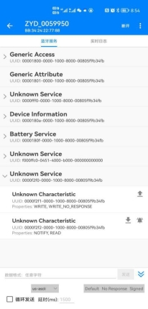
AT commands are used to set some parameters of Bluetooth devices, which are sent and received in ASCII code format

Bluetooth Broadcast Name Query and Settings
directive | Answer | Parameters
Query: AT+NAME? | OK+NAME:Para | Para: Module name  Up to 11 characters are allowed, including letters, numbers, underscores  默认 To=HW_ZAxx
设置:AT+NAME[For] | OK+NAME:Para

Set/query encryption mode
directive | Answer | Parameters
Enquiry: AT+TYPE? | OK+TYPE:Para | Para: encryption mode  A: No verification required  B: Application-layer password encryption  Default: A
设置:AT+TYPE[For] | OK+TYPE:Para

Set/look up passwords
directive | Answer | Parameters
验证密码:AT+PWD[For] | 验证成功:OK+PWD:Y  验证失败:OK+PWD:N | Para: Password6 digits Default: 888888
设置密码:AT+PWDM[For] | 回复 0K+PWDM:Para | Para: Password6 digits Default: 888888

Example (without encryption):
Check the Bluetooth broadcast name:
The command format uses ASCII code to send and receive.
Write: AT+NAME?
Notify: OK+NAME:ZYD_0059950
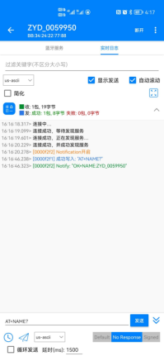

Modify Bluetooth Broadcast Name:
The command format uses ASCII code to send and receive.
Write: AT+NAME[AAABBBCCCDD]
Notify: OK+NAME:AAABBBCCCDD
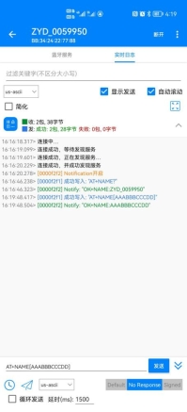
Successful modification:
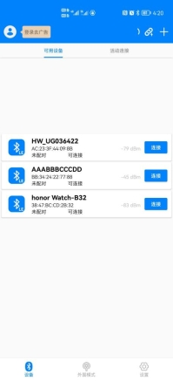

5. VCU upgrade service
Upgrade the service UUID:f000ffc0-0451-4000-b000-000000000000
Upgrade to receive UUID:f000ffc1-0451-4000-b000-000000000000
Upgrade to send UUID:f000ffc2-0451-4000-b000-000000000000

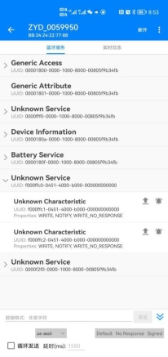
Meter upgrades through the service

The upgrade file is a .bin file, where the first 16 bytes of the bin file are the upgrade firmware information, and the first 16 bytes are the upgrade data.
The following figure shows the first part of the bin file:
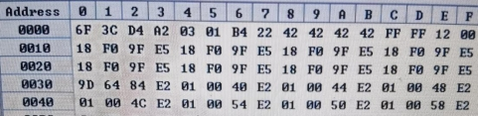
The first 16 bytes are parsed as follows (low bytes first):
Byte0-Byte3 upgrades the checksum bytes
byte4-byte5 待升级vcu版本号
Data 0x00 0x22 corresponding version number V2.2
Byte6-Byte7 upgrade file length in words (4 bytes).
Data 0xB4 0x22 Corresponding length 0x22B4
byte8-byte11 升级类型
Data 0x42 0x42 0x42 0x42 Upgrade Meter Program
Byte12-Byte13 Reserved
byte14-byte15 蓝牙协议栈版本
The data 0x12 0x00 corresponding version number V0.12
The app needs to check whether the version number of the instrument to be upgraded is different from the current version number of the instrument.
Instrument upgrade flow chart:

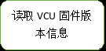

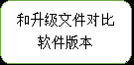

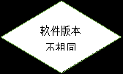

N
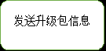
And

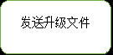

N



Y N

Read VCU firmware version information
App发送: UUID:f000ffc1-0451-4000-b000-00000000000000
Serial number | Byte definition | Example
0 | directive | 0x00
VCU回复： UUID：f000ffc1-0451-4000-b000-000000000000
Serial number | Byte definition | Example
0 | VCU version number is 8 digits lower | 0x1A
1 | The VCU version number is 8 digits higher | 0x00
2 | The firmware package length is low bytes | 0xB4
3 | The length of the firmware package is high bytes | 0x22
4 | Uid0 | 0x42
5 | Uid1 | 0x42
6 | Uid2 | 0x42
7 | Uid3 | 0x42
8 | The BLE stack version is 8 bits lower | 0x12
9 | The BLE stack version is 8 bits higher | 0x00
The app can only use the VCU version, and you don't need to pay attention to other data.

Send the upgrade package information
The content sent is the first 16 bytes of the upgrade package
App发送: f000ffc1-0451-4000-b000-000000000000
Serial number | Byte definition | Example
0 | Firmware package verification bytes | 0X6F
1 | Firmware package verification bytes | 0x3C
2 | Firmware package verification bytes | 0xD4
3 | Firmware package verification bytes | 0xA2
4 | VCU version number is 8 digits lower | 0x03
5 | The VCU version number is 8 digits higher | 0x01
6 | The firmware package length is low bytes | 0xB4
7 | The length of the firmware package is high bytes | 0x22
8 | Uid0 | 0x42
9 | Uid1 | 0x42
10 | Uid2 | 0x42
11 | Uid3 | 0x42
12 | Retained | 0xFF
13 | Retained | 0xFF
14 | The BLE stack version is 8 bits lower | 0x12
15 | The BLE stack version is 8 bits higher | 0x00
VCU回复： f000ffc2-0451-4000-b000-000000000000
Serial number | Byte definition | Example
0 | The package number is 8 digits lower | 0x00
1 | The package number is 8 digits higher | 0x00
It should be noted that the VCU reply is via FFC2

Send the upgrade file
App发送: f000ffc2-0451-4000-b000-000000000000
The app needs to split the entire upgrade file into 16 bytes per package and send it to VCU, and the package number needs to be automatically added by 1, and the app can be sent at intervals of 10ms per package
Serial number | Byte definition | Example
0 | The package number is 8 digits lower | 0x00
1 | The package number is 8 digits higher | 0x00
2-17 | Upgrade data 16 bytes

Vcu回复： f000ffc2-0451-4000-b000-000000000000
Only the VCU will receive an error in the data will reply The reply content is the package number, and the app needs to continue sending it down from the location of the received package number after receiving the reply
Serial number | Byte definition | Example
0 | The package number is 8 digits lower | 0x##
1 | The package number is 8 digits higher | 0x##

Example (without encryption):
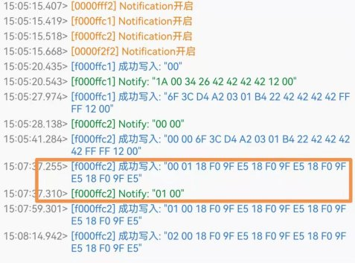

If the app in the box is in the wrong format, the VCU will reply to the package number and remind the app that it needs data with the package number 0x01 0x00.

CRC
The CRC calculation range includes all bytes except CRC bytes, and the CRC calculation can directly call CalculateCRC16(), and the return value is the calculated CRC value.

const unsigned char CRCH[] =
{
0x00,0xC1,0x81,0x40,0x01,0xC0,0x80,0x41,0x01,0xC0,0x80,0x41,0x00,0xC1,0x81,
0x40,0x01,0xC0,0x80,0x41,0x00,0xC1,0x81,0x40,0x00,0xC1,0x81,0x40,0x01,0xC0,
0x80,0x41,0x01,0xC0,0x80,0x41,0x00,0xC1,0x81,0x40,0x00,0xC1,0x81,0x40,0x01,
0xC0,0x80,0x41,0x00,0xC1,0x81,0x40,0x01,0xC0,0x80,0x41,0x01,0xC0,0x80,0x41,
0x00,0xC1,0x81,0x40,0x01,0xC0,0x80,0x41,0x00,0xC1,0x81,0x40,0x00,0xC1,0x81,
0x40,0x01,0xC0,0x80,0x41,0x00,0xC1,0x81,0x40,0x01,0xC0,0x80,0x41,0x01,0xC0,
0x80,0x41,0x00,0xC1,0x81,0x40,0x00,0xC1,0x81,0x40,0x01,0xC0,0x80,0x41,0x01,
0xC0,0x80,0x41,0x00,0xC1,0x81,0x40,0x01,0xC0,0x80,0x41,0x00,0xC1,0x81,0x40,
0x00,0xC1,0x81,0x40,0x01,0xC0,0x80,0x41,0x01,0xC0,0x80,0x41,0x00,0xC1,0x81,
0x40,0x00,0xC1,0x81,0x40,0x01,0xC0,0x80,0x41,0x00,0xC1,0x81,0x40,0x01,0xC0,
0x80,0x41,0x01,0xC0,0x80,0x41,0x00,0xC1,0x81,0x40,0x00,0xC1,0x81,0x40,0x01,
0xC0,0x80,0x41,0x01,0xC0,0x80,0x41,0x00,0xC1,0x81,0x40,0x01,0xC0,0x80,0x41,
0x00,0xC1,0x81,0x40,0x00,0xC1,0x81,0x40,0x01,0xC0,0x80,0x41,0x00,0xC1,0x81,
0x40,0x01,0xC0,0x80,0x41,0x01,0xC0,0x80,0x41,0x00,0xC1,0x81,0x40,0x01,0xC0,
0x80,0x41,0x00,0xC1,0x81,0x40,0x00,0xC1,0x81,0x40,0x01,0xC0,0x80,0x41,0x01,
0xC0,0x80,0x41,0x00,0xC1,0x81,0x40,0x00,0xC1,0x81,0x40,0x01,0xC0,0x80,0x41,
0x00,0xC1,0x81,0x40,0x01,0xC0,0x80,0x41,0x01,0xC0,0x80,0x41,0x00,0xC1,0x81,
0x40
};

const unsigned char CRCL[] =
{
0x00,0xC0,0xC1,0x01,0xC3,0x03,0x02,0xC2,0xC6,0x06,0x07,0xC7,0x05,0xC5,0xC4,
0x04,0xCC,0x0C,0x0D,0xCD,0x0F,0xCF,0xCE,0x0E,0x0A,0xCA,0xCB,0x0B,0xC9,0x09,
0x08,0xC8,0xD8,0x18,0x19,0xD9,0x1B,0xDB,0xDA,0x1A,0x1E,0xDE,0xDF,0x1F,0xDD,
0x1D,0x1C,0xDC,0x14,0xD4,0xD5,0x15,0xD7,0x17,0x16,0xD6,0xD2,0x12,0x13,0xD3,
0x11,0xD1,0xD0,0x10,0xF0,0x30,0x31,0xF1,0x33,0xF3,0xF2,0x32,0x36,0xF6,0xF7,
0x37,0xF5,0x35,0x34,0xF4,0x3C,0xFC,0xFD,0x3D,0xFF,0x3F,0x3E,0xFE,0xFA,0x3A,
0x3B,0xFB,0x39,0xF9,0xF8,0x38,0x28,0xE8,0xE9,0x29,0xEB,0x2B,0x2A,0xEA,0xEE,
0x2E,0x2F,0xEF,0x2D,0xED,0xEC,0x2C,0xE4,0x24,0x25,0xE5,0x27,0xE7,0xE6,0x26,
0x22,0xE2,0xE3,0x23,0xE1,0x21,0x20,0xE0,0xA0,0x60,0x61,0xA1,0x63,0xA3,0xA2,
0x62,0x66,0xA6,0xA7,0x67,0xA5,0x65,0x64,0xA4,0x6C,0xAC,0xAD,0x6D,0xAF,0x6F,
0x6E,0xAE,0xAA,0x6A,0x6B,0xAB,0x69,0xA9,0xA8,0x68,0x78,0xB8,0xB9,0x79,0xBB,
0x7B,0x7A,0xBA,0xBE,0x7E,0x7F,0xBF,0x7D,0xBD,0xBC,0x7C,0xB4,0x74,0x75,0xB5,
0x77,0xB7,0xB6,0x76,0x72,0xB2,0xB3,0x73,0xB1,0x71,0x70,0xB0,0x50,0x90,0x91,
0x51,0x93,0x53,0x52,0x92,0x96,0x56,0x57,0x97,0x55,0x95,0x94,0x54,0x9C,0x5C,
0x5D,0x9D,0x5F,0x9F,0x9E,0x5E,0x5A,0x9A,0x9B,0x5B,0x99,0x59,0x58,0x98,0x88,
0x48,0x49,0x89,0x4B,0x8B,0x8A,0x4A,0x4E,0x8E,0x8F,0x4F,0x8D,0x4D,0x4C,0x8C,
0x44,0x84,0x85,0x45,0x87,0x47,0x46,0x86,0x82,0x42,0x43,0x83,0x41,0x81,0x80,
0x40
};
/*************************************************************************
* *msgPtr needs to calculate the first address of the CRC data
* msgLen needs to calculate the length of the CRC data
* return calculated CRC value
*************************************************************************/
unsigned short int CalculateCRC16(unsigned char *msgPtr, unsigned short int msgLen)
{
unsigned char crcHigh = 0xFF; //high byte of CRC initialized
unsigned char crcLow = 0xFF; //low byte of CRC initialized
unsigned char index; //will index into CRC lookup table

while (msgLen--) //pass through message buffer
{
index = crcLow ^ (*(msgPtr++)); //calculate the CRC
crcLow = crcHigh ^ CRCH[index];
crcHigh = CRCL[index];
}
return (unsigned short int)((unsigned short int)(crcHigh<<8) | crcLow);
}

Data encryption

Encryption
We use encryption similar to single-table substitution, replacing 0-F with random numbers.
For example:
Key[16]={0x02,0x03,0x07,0x09,0x0A,0x01,0x04,0x08,0x0F,0x06,0x0D,0x0C,0x05,0x0B,0x00,0x0E};
0->2 1->3 2->7 3->9 4->A 5->1 6->4 7->8 8->F 9->6 A->D B->C C->5 D->B E->0 F->E
明文：tab[3] = {0x0F,0x12,0xE3}
密文：tab[3] = {0x2E,0x37,0x09}

For enhanced encryption, we employ 16 sets of keys
unsigned char const Key[16][16]={
{0x02,0x03,0x07,0x09,0x0A,0x01,0x04,0x08,0x0F,0x06,0x0D,0x0C,0x05,0x0B,0x00,0x0E},//0
{0x01,0x06,0x0A,0x05,0x07,0x02,0x0E,0x00,0x0C,0x03,0x0B,0x0F,0x09,0x0D,0x08,0x04},//1
{0x0F,0x03,0x09,0x07,0x0E,0x04,0x01,0x08,0x02,0x0D,0x06,0x00,0x05,0x0B,0x0C,0x0A},//2
{0x01,0x06,0x0F,0x09,0x0A,0x02,0x04,0x0D,0x07,0x03,0x08,0x00,0x05,0x0B,0x0C,0x0E},//3
{0x00,0x03,0x07,0x0E,0x08,0x01,0x0B,0x0A,0x0F,0x06,0x0D,0x0C,0x05,0x04,0x02,0x09},//4
{0x0F,0x00,0x0A,0x02,0x07,0x03,0x04,0x08,0x09,0x06,0x0C,0x0D,0x05,0x0B,0x01,0x0E},//5
{0x03,0x02,0x09,0x07,0x01,0x0A,0x0F,0x06,0x04,0x08,0x00,0x0C,0x0E,0x0B,0x0D,0x05},//6
{0x07,0x03,0x02,0x09,0x0F,0x0D,0x0A,0x08,0x0B,0x06,0x01,0x0C,0x05,0x04,0x00,0x0E},//7
{0x02,0x03,0x0B,0x01,0x0A,0x09,0x05,0x08,0x0C,0x07,0x0D,0x0F,0x04,0x06,0x0E,0x00},//8
{0x01,0x03,0x04,0x09,0x05,0x02,0x07,0x00,0x0E,0x06,0x0D,0x08,0x0A,0x0B,0x0C,0x0F},//9
{0x00,0x07,0x0D,0x0B,0x0A,0x06,0x04,0x08,0x0F,0x01,0x03,0x0C,0x05,0x0E,0x02,0x09},//A
{0x0F,0x03,0x0E,0x0B,0x06,0x08,0x04,0x01,0x02,0x0C,0x0D,0x0A,0x05,0x00,0x09,0x07},//B
{0x08,0x0C,0x07,0x0E,0x0A,0x01,0x06,0x02,0x0F,0x04,0x0D,0x03,0x00,0x0B,0x05,0x09},//C
{0x02,0x0E,0x0A,0x07,0x09,0x06,0x04,0x08,0x00,0x01,0x05,0x0C,0x0D,0x0B,0x0F,0x03},//D
{0x0E,0x00,0x0B,0x05,0x0C,0x0D,0x0F,0x06,0x04,0x08,0x01,0x0A,0x09,0x07,0x03,0x02},//E
{0x01,0x0F,0x03,0x07,0x06,0x00,0x0D,0x0C,0x02,0x09,0x0E,0x05,0x08,0x0A,0x0B,0x04},//F
};
Select the key by accumulating and lowering the four digits by Serial Number
For example, SN is "0123456789123"
秘钥为 Key[keytype][16]
Sum = 0x30+0x31+0x32+0x33+0x34+0x35+0x36+0x37+0x38+0x39+0x31+0x32+0x33
Sum = 0x02A3
keytype= Sum & 0x000F keytype= 0x0003
Ki[keytipe][16] = ki[3][16] =
{0x01,0x06,0x0F,0x09,0x0A,0x02,0x04,0x0D,0x07,0x03,0x08,0x00,0x05,0x0B,0x0C,0x0E},//3

/*Encrypted*/
/**********************************************************************************
*parameter *tabIn The data header address (plaintext) that needs to be encrypted
*Parameter *tabOutThe first address (ciphertext) of the encrypted data is stored
*Parameter len The length of the data that needs to be encrypted
*Parameter type key selection
**********************************************************************************/
void encrypt(unsigned char *tabIn,unsigned char *tabOut,unsigned char len,unsigned char type)
{
unsigned char i=0;
unsigned char codeL,codeH;

for(i=0; i<len; i++)
{
codeL = tabIn[i]&0x0F;
codeH = (tabIn[i]&0xF0)>>4;
tabOut[i] = 0;
tabOut[i] |= key[type][codeL];
tabOut[i] |= (key[type][codeH]<<4);
}

}
/*decrypt*/
/**********************************************************************************
*parameter *tabIn The data header address (ciphertext) that needs to be decrypted
*parameter *tabOut: The first address of the decrypted data (plaintext).
*The parameter len requires the length of the data to be decrypted
*Parameter type key selection
**********************************************************************************/
void decrypt(unsigned char *tabIn,unsigned char *tabOut,unsigned char len,unsigned char type)
{
unsigned char i=0,j=0;
unsigned char codeL,codeH;

for(i=0; i<len; i++)
{
codeL = tabIn[i]&0x0F;
codeH = (tabIn[i]&0xF0)>>4;
tabOut[i] = 0;
for(j=0; j<16; j++)
{
if(codeL==key[type][j])
{
tabOut[i] |= j;
}
if(codeH==key[type][j])
{
tabOut[i] |=(j<<4);
}
}
}
}

Example:
Send the mobile phone to send the command code to read the skateboard information:
Before encryption: F0 B0 05 C4 30
Encryption is used with the key [3][16]
After encryption: E1 01 12 5A 91

Encrypted byte description
- Device Information的Serial Number 不用加密
- When VCU is upgraded, the package number of the upgrade data is not encrypted
- When the VCU is upgraded, the number of bytes sent or replied to is less than 3 bytes is not encrypted
In addition to the above points, all other data needs to be encrypted.


